1.

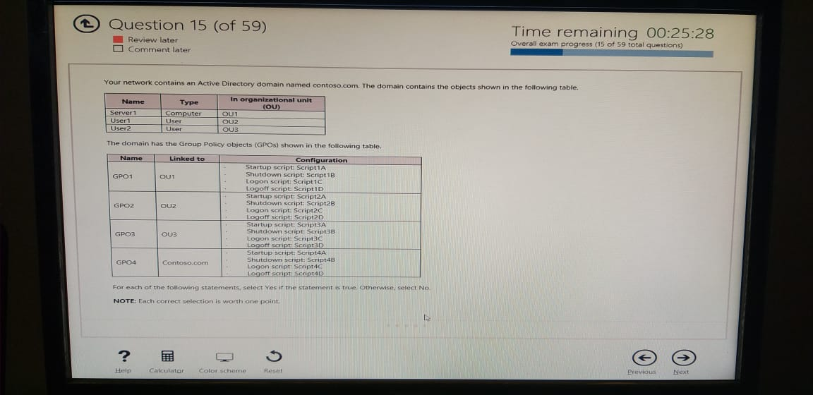Your network contains an Active Directory domain named contoso.com. The domain contains the objects shown in the following table.

The domain has the Group Policy objects (GPOs) shown in the following table.

For each of the following statements, select Yes if the statement is true. Otherwise select No

NOTE: Each correct selection is worth one point.

|  |  |  |
| --- | --- | --- |
| Statements | Yes | No |
| If User 1 signs into Server 1, Script1C runs |  |  |
| If User 2 signs into Server 1, Script4C runs |  |  |
| If user 2 restarts Server1, Script3D runs |  |  |

Answer: No, Yes, No

2.

Your network contains an Active Directory forest. The forest contains two sites named Site1 and Site2. Site1 contains 10 domain controllers. Site 1 and Site2 connect to each other by using a WAN link.

You run the Active Directory Domain Services Configuration Wizard as shown in the following graphic

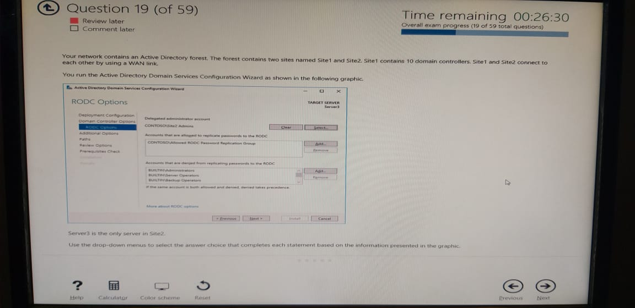

Server3 is the only server in Site2.

Use the drop-down menus to select the answer choice that completes each statement based on the information presented in the graphic

Answer Area:

Members of the Site2 Admins group will be able to [answer

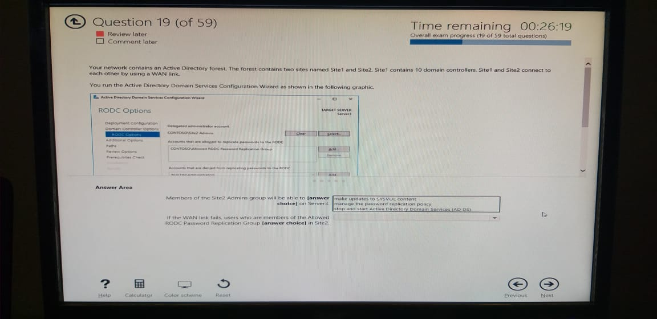choice] on Server3:

If the WAN link fails, users who are members of the Allowed

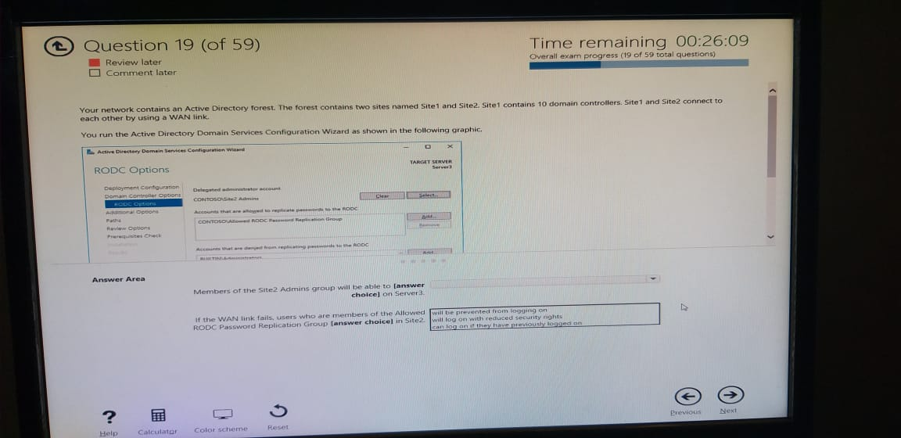RODC Password Replication Group [answer choice] in Site2:

Answer:

3.

Your network contains an Active Directory domain named adatum.com.

You create a user named User 1.

You need to meet the following requirements:

* Ensure that User1 can sign in only during work hours.
* Allow User1 to establish a VPN connection

Which two settings should you configure? To answer, select the appropriate settings in the answer area.

NOTE: Each correct selection is worth one point.

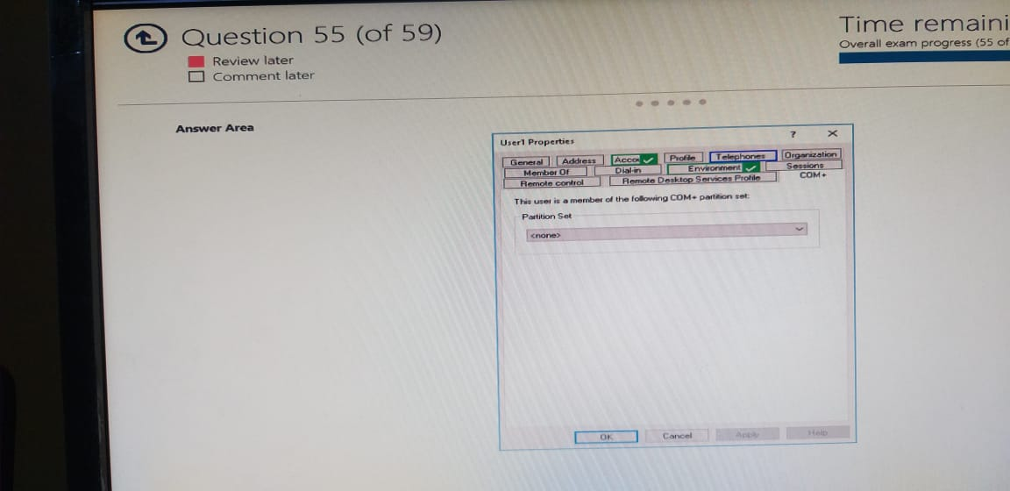Answer Area:

4.

Your network contains an Active Directory forest. The forest functional level is Windows Server 2016. The network contains Linux servers that use MIT Kerberos V5 to provide an authentication, authorization, and access service.

You need to ensure that users can use their Active Directory credentials to access the resources on the Linux servers. The solution must minimize administrative effort.

What should you implement?

1. Active Directory Federation Services (AD FS)
2. an external trust
3. a realm trust
4. a Web Application Proxy

Answer: C

5.

Your network contains an Active Directory forest. The forest contains a forest root domain named contoso.com and a child domain named eu.contoso.com. Each domain contains two domain controllers that run Windows Server 2012 R2.

The forest functional level is Windows Server 2008 R2. The domain functional level of contoso.com is Windows Server 2012 R2. The domain functional level of eu.contoso.com is Windows Server 2008 R2

You need to raise the domain functional level of contoso.com to Windows Server 2016. The solution must minimize administrative effort.

What should you do before you raise the domain functional level?

1. Raise the forest functional level.
2. Upgrade all of the domain controllers in the forest.
3. Upgrade all of the domain controllers in contoso.com
4. Raise the domain functional level of eu.contoso.com

Answer: A

6.

Your network contains an Active Directory domain named contoso.com. The domain contains a read-only domain controller (RODC) named RODC1.

The domain contains the users shown in the following table

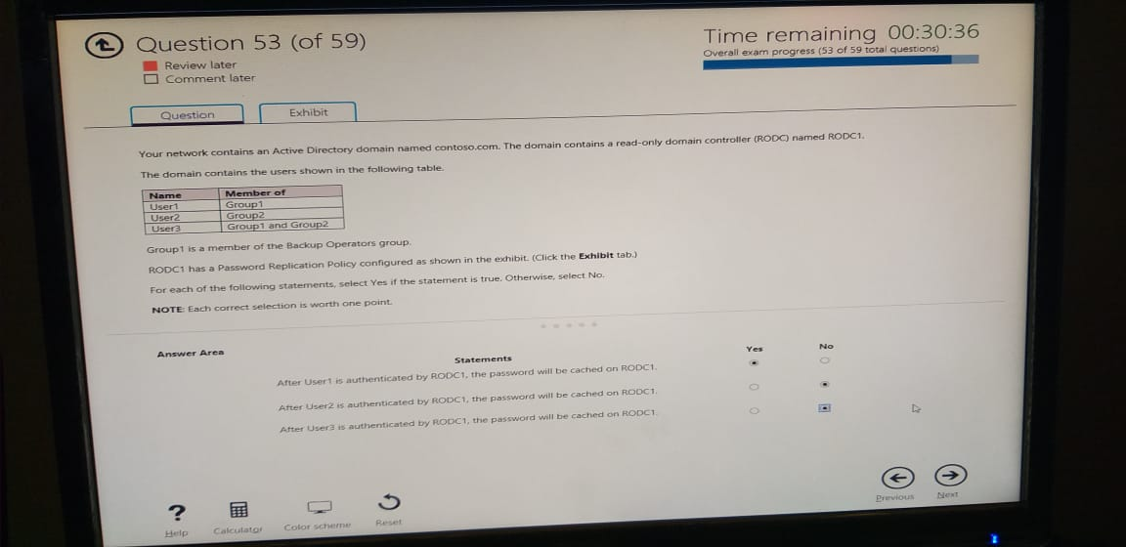

Group1 is a member of the Backup Operators group.

RODC1 has a Password Replication Policy configured as shown in the exhibit. (Click the Exhibit tab.)

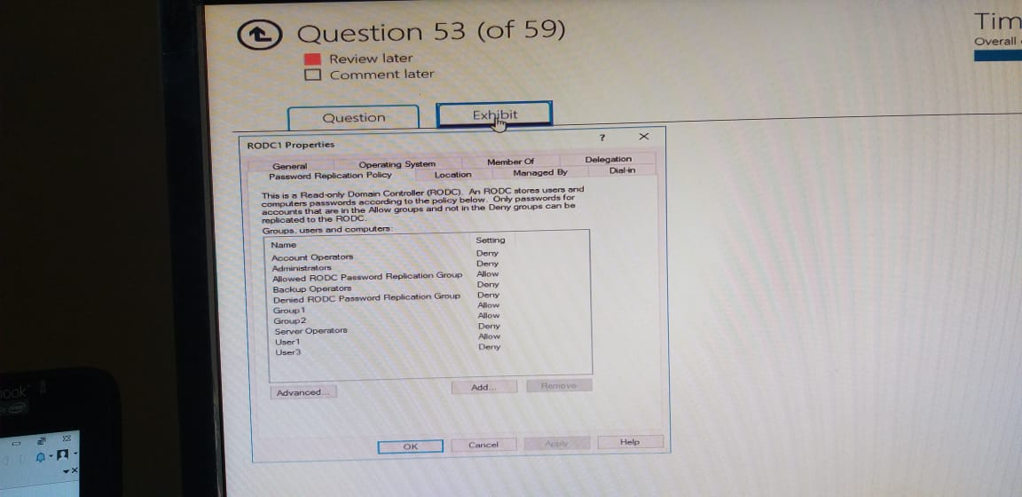

For each of the following statements, select Yes if the statement is true. Otherwise, select No.

NOTE Each correct selection is worth one point

Answer Area:

|  |  |  |
| --- | --- | --- |
| Statements | Yes | No |
| After User1 is authenticated by RODC1, the password will be cached on RODC1 |  |  |
| After User2 is authenticated by RODC1, the password will be cached on RODC1 |  |  |
| After User3 is authenticated by RODC1, the password will be cached on RODC1 |  |  |

Answer: Yes, No, No

7.

Your network contains an Active Directory forest named adatum.com. A partner organization has an Active Directory forest named contoso.com. Adatum.com contains an Active Directory Rights Management Services (AD RMS) cluster installed on a server named adat1.adatum.com. Contoso.com contains an Active Directory Rights Management Services (AD RMS) cluster installed on a server named cont1.contoso.com. You need to allow the AD RMS cluster in adatum.com to accept rights account certificates (RACs) from contoso.com. What should you do?

1. In contoso.com, import the trusted user domain file from adat1.adatum.com.
2. In adatum.com, import the trusted user domain file from cont1.contoso.com.
3. In contoso.com, import the trusted publishing domain file from cont1.contoso.com.
4. In adatum.com, import the trusted publishing domain file from adat1.adatum.com

Answer: B

8.

Note: This question is part of a series of questions that use the same scenario. For your convenience, the scenario is repeated in each question. Each question presents a different goal and answer choices, but the text of the scenario is exactly the same in each question in this series.

**Start of repeated scenario**

You work for a company named Contoso, Ltd

The network contains an Active Directory forest named contoso.com. A forest trust exists between contoso.com and an Active Directory forest named adatum.com

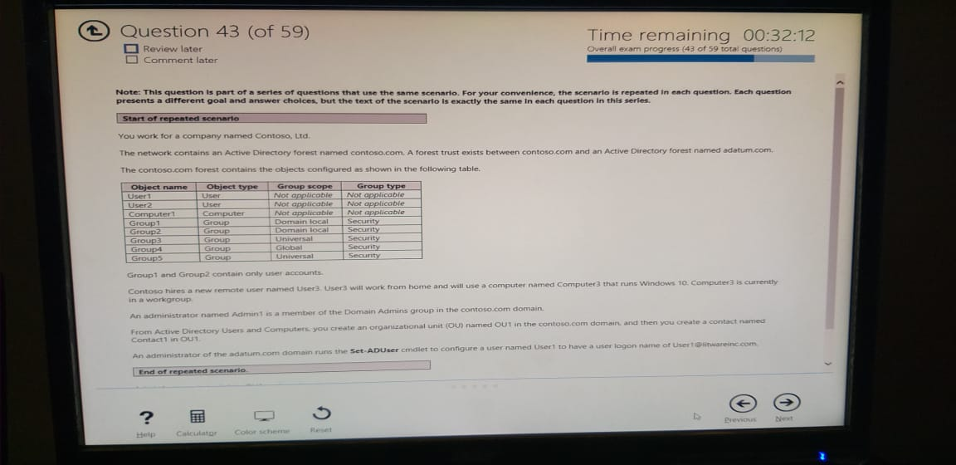The contoso.com forest contains the objects configured as shown in the following table.

Group1 and Group2 contain only user accounts

Contoso hires a new remote user named User3, User3 will work from home and will use a computer named Computer3 that runs Windows 10. Computer3 is currently in a workgroup.

An administrator named Admin1 is a member of the Domain Admins group in the contoso.com domain. From Active Directory Users and Computers, you create an organizational unit (OU) named OU1 in the contosa.com domain and then you create a contact named Contact1 in OU1

An administrator of the adaturn.com domain runs the Set-ADUser cmdlet to configure a user named user to have a user logon name of User1@Ntwareinc.com

**End of repeated scenario**

Admin 1 attempts to delete OU1 and receives an error message.

You need to ensure that Admin1 can delete OU1

What should you do first?

1. Disable the Active Directory Recycle Bin
2. Delete Contact
3. Modify the object settings for OUT
4. Add Admin1 to the Enterprise Admins group

Answer: D

9.

Your network contains an Active Directory domain named contoso.com.

You have an organizational unit (OU) named OU1. A Group Policy object (GPO) named GPO1 is linked to OU1. You create a user named User1, and you assign User1 the full control permission to OU1. Which administrative action for GPOs can User1 perform?

1. Link an existing GPO from the domain to OU1.
2. Create a new GPO and link the GPO to OU1.
3. Add an administrative template to GPO1.
4. Edit the User Rights Assignment in GPO1.

Answer: C

10.

You deploy a Remote Desktop server named RDP1. RDP1 has two volumes named C and D. You plan to allow users to connect to RDP1 to run multiple applications.

You need to ensure that when the users establish a Remote Desktop connection to RDP1, volume D is hidden

What should you do? To answer, select the appropriate options in the answer area.

NOTE: Each correct selection is worth one point,

Answer Area:

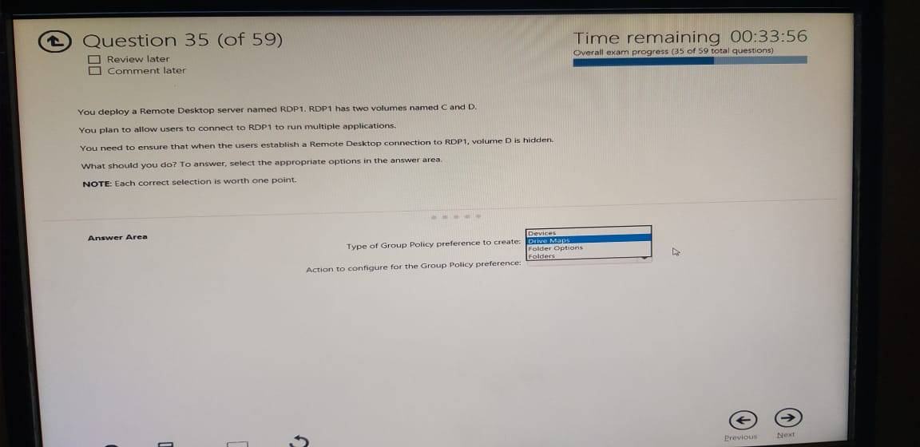Type of Group Policy preference to create:

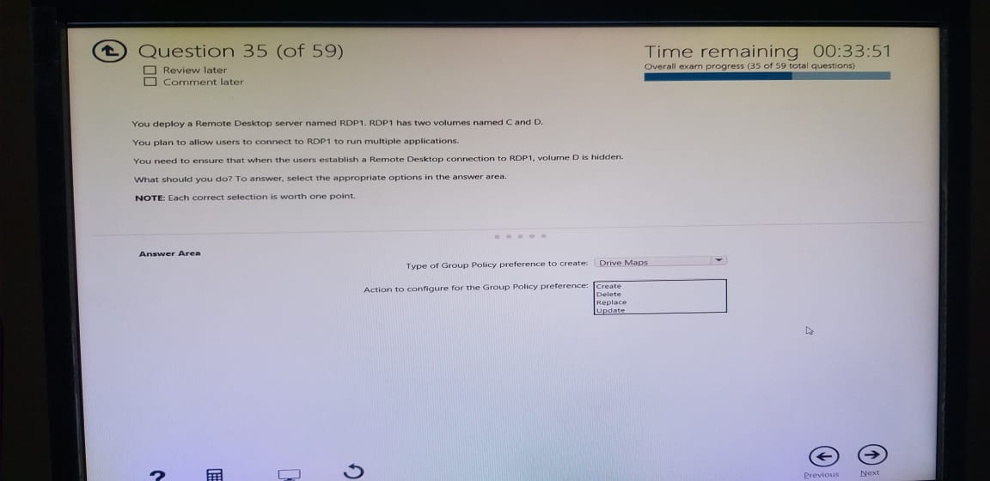Action to configure for the Group Policy preference:

Answer: Drive Maps, Update